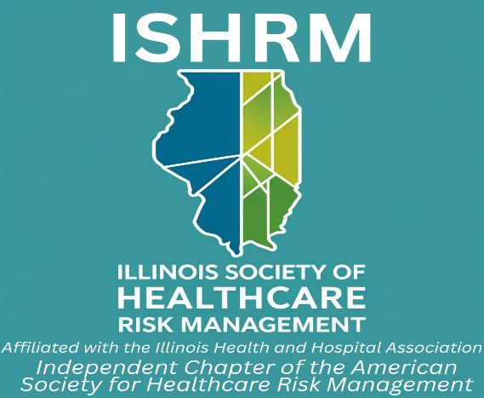

Scholarship Application

Applicant Name _____________________________________________

Home Address ____________________________________________

____________________________________________
Work Phone Number _________________ Cell Phone _______________

Email Address ____________________________________________

Current Place of Employment ____________________________________

Current Job Title ____________________________________________

Description of interest in continuing/advancing knowledge/education in the area of healthcare risk management; how the award will impact academic and/or career goals; demonstrate how newly learned methods and skills will be applied to improve the
organization’s overall risk management/patient safety program, if employed:

Current individual professional and/or scholastic experience, activities and accomplishments:

If applicable, current class standing (enrollee, undergraduate, graduate, doctoral candidate, etc.):

If applicable, major, minor fields of study:

If applicable, academic GPA in field of study and overall GPA:

Please attach your Resume or CV that details work/scholastic experience related to risk management and/or patient safety. Please attach a letter of recommendation from an ISHRM member/colleague/employer or academic.
a. Letter can be from current or past employer, defined as “an individual who serves or has served in a supervisory capacity to the applicant”.
b. Letter must provide details on the current position and the applicant’s responsibilities as they relate to the risk management/patient safety field. It should also verify the organization’s (employer’s) ability to provide funding to cover the cost for professional development (if the organization will cover partial cost, the amount should be included) or if not employed, individual needs.

